EXPT NO:6 | INTEGRATE DATA FROM VARIOUS SOURCES FOR COMPREHENSIVE ANALYSIS USING TABLEAU AND POWERBI
DATE: 24.07.2026

Name : Arunagiri R
Roll no : 24BAD013

PRE-LAB QUESTIONS

- What is data integration in the context of Business Intelligence (BI)?
Data integration is the process of combining data from different sources into a single, unified dataset. It helps organizations analyze information more effectively and make better business decisions.

- Explain the difference between a join and a data blend in Tableau.
A join combines tables from the same data source into one table before analysis. A data blend combines data from different data sources during analysis by linking them using a common field.

- What are relationships and cardinality (e.g., one-to-many, many-to-many) in Power BI's data model?
Relationships connect tables using common columns. Cardinality defines how records in one table relate to another, such as one-to-many, one-to-one, or many-to-many, ensuring accurate data analysis.

- Why is data quality (e.g., consistent naming conventions, data types) crucial when integrating data from different sources?
Good data quality ensures accurate matching of records, reduces errors, and improves the reliability of reports and dashboards. Consistent names and data types make integration easier and more accurate.

- Name two common challenges encountered during data integration.
• Inconsistent data formats or naming conventions.
• Missing or duplicate data that affects analysis

IN-LAB EXERCISE:
OBJECTIVE:
To connect to, combine, and model data from multiple disparate sources in Tableau and Power BI to create a unified, comprehensive dashboard for holistic analysis. PROCEDURE:
- Data Collection:
  - Import data from at least two different sources (e.g., a CSV file and an Excel file).
  - Dataset 1: Sales Data (CSV file) with fields like Order ID, Order Date, Region, Sales Amount.
  - Dataset 2: Regional Sales Targets (Excel file) with fields like Region, Sales Target, Target Year.
- Data Preparation and Transformation:
  - Clean both datasets: Check for inconsistencies in region names (e.g., "N. America" vs. "North America"). o Ensure data types are correct (e.g., Sales Amount is numeric, Order Date is a date).
  - Handle any missing values as appropriate.
- Data Integration and Modeling:
  - Tableau: Use the Data Source pane to establish a relationship or join between the Sales Data and Regional Targets tables using the common Region field.
  - Power BI: Use the Model view to create a relationship between the two tables, connecting them on the Region column. Define the cardinality (e.g., many-to-one).
- Create Calculated Fields for Comparison:
  - Develop new measures that leverage both datasets.
  - Examples: Target Achievement % = (SUM(Sales) / SUM(Sales Target)) * 100
  - Sales vs. Target Variance = SUM(Sales) - SUM(Sales Target)
- Design a Comprehensive Dashboard:
  - Create visuals that combine data from both sources to provide a single view of performance.
  - Add KPI cards for Total Sales and Overall Target Achievement %. o Use a gauge chart or bullet chart to show sales performance against targets for each region. o Create a combined bar chart showing Actual Sales vs. Target Sales by Region.
  - Use a map to visualize the Sales vs. Target Variance, highlighting underperforming or overperforming regions.
- Validate Data Integrity:
  - Verify that the joined/related data is accurate by cross-checking values. o Ensure filters on the dashboard correctly update visuals that use data from both sources.
- Publishing and Sharing:
  - Tableau: Publish the workbook to Tableau Public or Tableau Server.
  - Power BI: Publish the report to Power BI Service and share the link.

Screenshots of PowerBI :

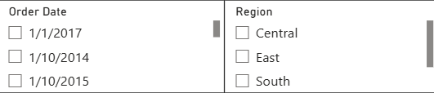
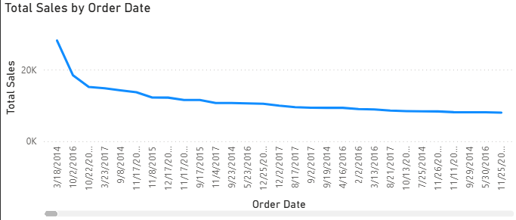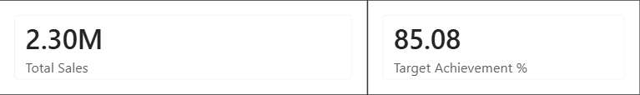

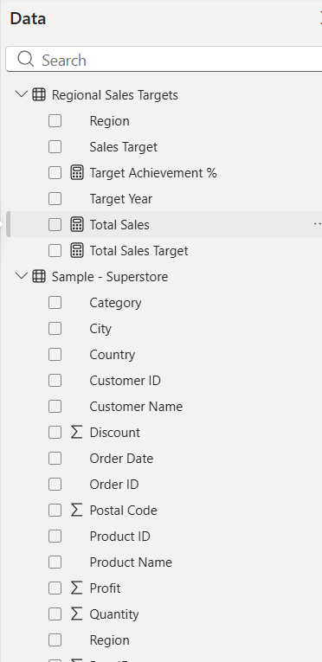
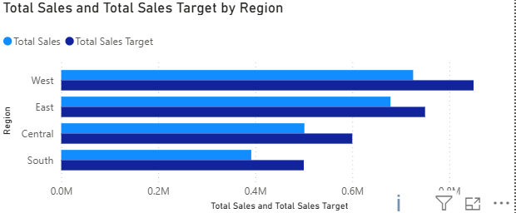

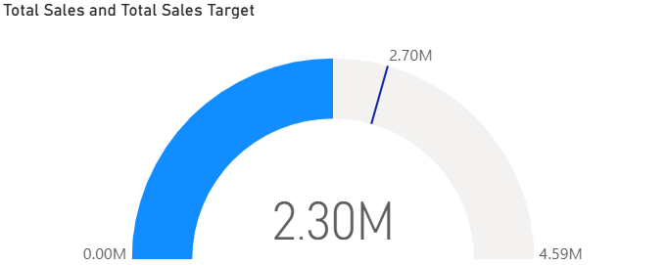
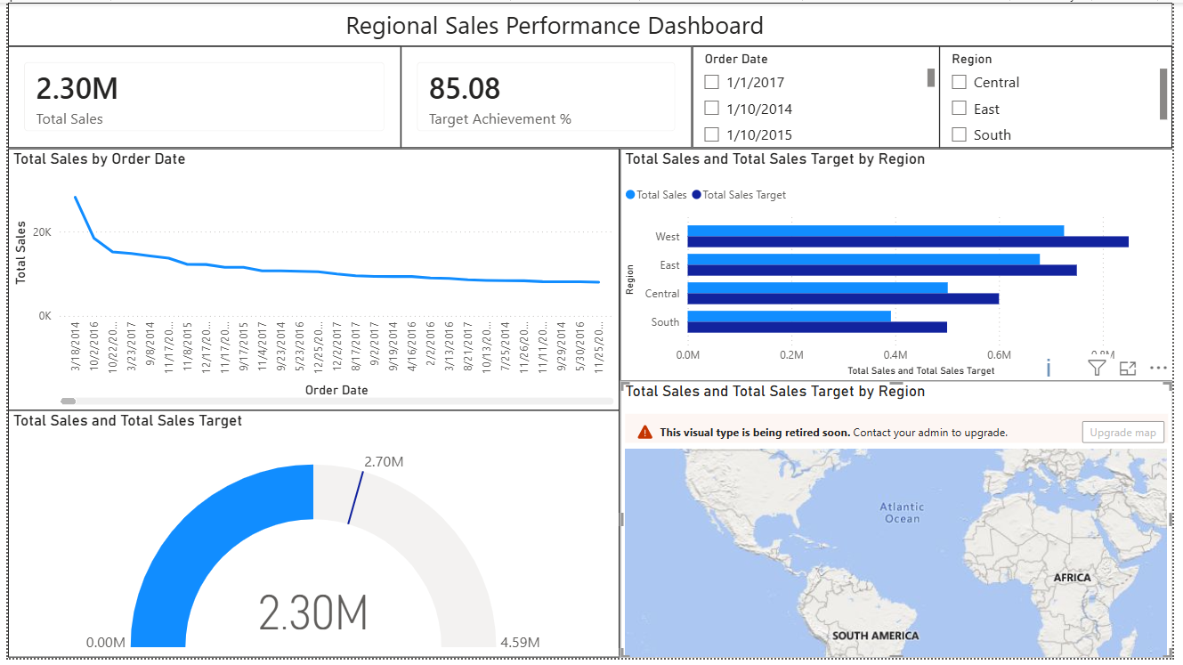

Screenshots of Tableau :

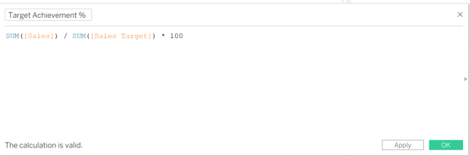
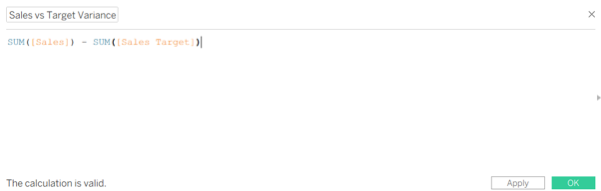
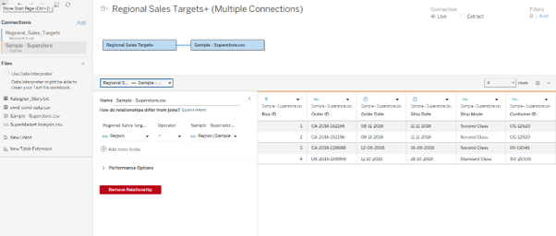
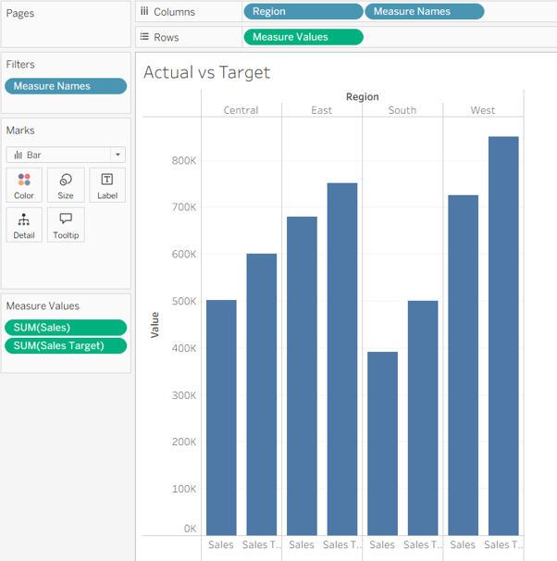
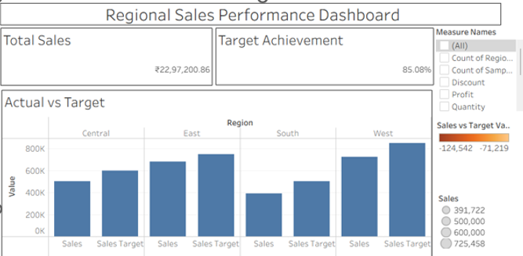

Experiment Datasets:
Dataset 1: Retail Sales Data (CSV) Fields Used:
- Order ID – Unique identifier for each order
- Order Date – Date of the sales transaction
- Region – Sales region
- Sales – Sales revenue from the order
Dataset 2: Regional Sales Targets (Excel) Fields Used:
- Region – Sales region (used as the key for joining/relationship)
- Sales Target – The sales goal for the region
- Target Year – The year for which the target is set

POST-LAB QUESTIONS
- How did integrating the sales targets data provide a more complete analytical picture than using the sales data alone?

Integrating the sales targets with the sales data allowed us to compare actual sales against planned goals. It helped measure regional performance, identify whether targets were achieved, and evaluate overall business success more effectively than using sales data alone.

- Describe the type of join or relationship you used to combine the two datasets and explain why it was the appropriate choice.
A relationship was created between the two datasets using the Region field. This was appropriate because both datasets shared the same region values, allowing Tableau to combine sales and target information without duplicating data and maintaining flexibility during analysis.

- What challenges, if any, did you face regarding data granularity or mismatched keys (e.g., different region names) between the two sources?

The main challenge was ensuring that the region names matched exactly in both datasets. Any differences in spelling or formatting could prevent the relationship from working correctly. Verifying data types and checking for missing values also helped avoid errors.

- How can creating variance calculations (e.g., Sales vs. Target) help a business manager make better decisions?
Variance calculations help managers quickly identify regions that are performing above or below their targets. This enables better decision-making, such as allocating resources, improving underperforming regions, and recognizing high-performing areas.

- What other data source (e.g., marketing campaign data, customer demographics) could you integrate to further enrich this analysis, and what new insights might it provide?
Customer demographic data or marketing campaign data could be integrated with the sales data. This would help analyze customer buying behavior, measure campaign effectiveness, identify profitable customer segments, and improve marketing and sales strategies.

RESULT:

The retail sales and regional targets datasets were successfully connected, cleaned, and integrated in both Tableau and Power BI. By creating relationships between the sources, a unified data model was built. The resulting comprehensive dashboard visualized sales performance against set targets, enabling variance analysis and providing deeper, context-rich insights into regional performance that were not possible with a single data source.

ASSESSMENT

Description |  | Max Marks | Marks Awarded
Pre Lab Exercise |  | 5
In Lab Exercise |  | 10
Post Lab Exercise |  | 5
Viva |  | 10
 | Total | 30
 | Faculty Signature

